WEEK – 2

PL/SQL PROGRAMMING

Exercise 1: Control Structures

Scenario 1: The bank wants to apply a discount to loan interest rates for customers above 60 years old.

Question: Write a PL/SQL block that loops through all customers, checks their age, and if they are above 60, apply a 1% discount to their current loan interest rates.
CODE :

CREATE TABLE Customers (
CustomerID NUMBER PRIMARY KEY,
Name VARCHAR2(50),
Age NUMBER,
Balance NUMBER,
IsVIP VARCHAR2(5) DEFAULT 'FALSE'
);

INSERT INTO Customers VALUES (1, 'Anita Rao', 62, 15000, 'FALSE');
INSERT INTO Customers VALUES (2, 'Ravi Kumar', 45, 9500, 'FALSE');
INSERT INTO Customers VALUES (3, 'Leela Das', 70, 18000, 'FALSE');
COMMIT;

SELECT * FROM Customers;

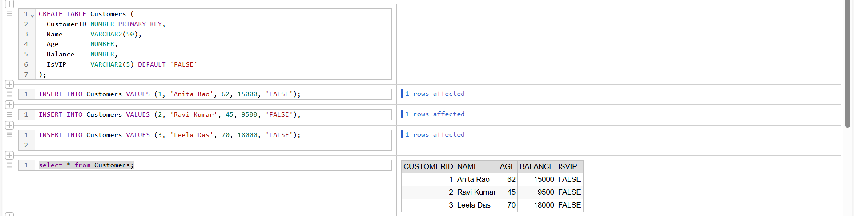

CREATE TABLE Loans (
LoanID NUMBER PRIMARY KEY,
CustomerID NUMBER,
InterestRate NUMBER,
DueDate DATE,
FOREIGN KEY (CustomerID) REFERENCES Customers(CustomerID)
);

INSERT INTO Loans VALUES (101, 1, 9.5, SYSDATE + 10);
INSERT INTO Loans VALUES (102, 2, 10.5, SYSDATE + 40);
INSERT INTO Loans VALUES (103, 3, 11.0, SYSDATE + 20);
COMMIT;

SELECT * FROM Loans;

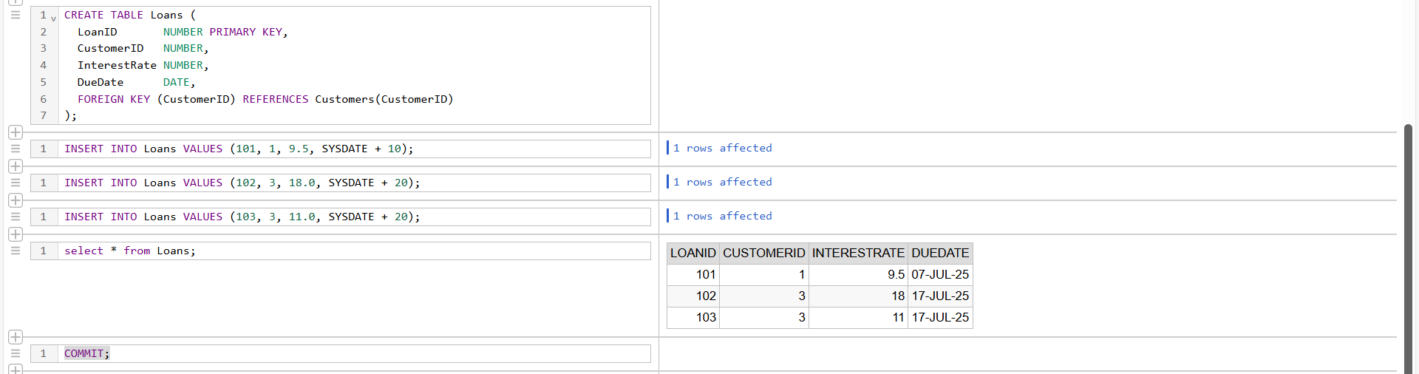

BEGIN
FOR rec IN (
SELECT LoanID, l.CustomerID, c.Name, c.Age, l.InterestRate
FROM Loans l
JOIN Customers c ON l.CustomerID = c.CustomerID
) LOOP
IF rec.Age > 60 THEN
UPDATE Loans
SET InterestRate = rec.InterestRate - 1
WHERE LoanID = rec.LoanID;

DBMS_OUTPUT.PUT_LINE(' Interest rate discounted for ' || rec.Name);
END IF;
END LOOP;
COMMIT;
END;
/

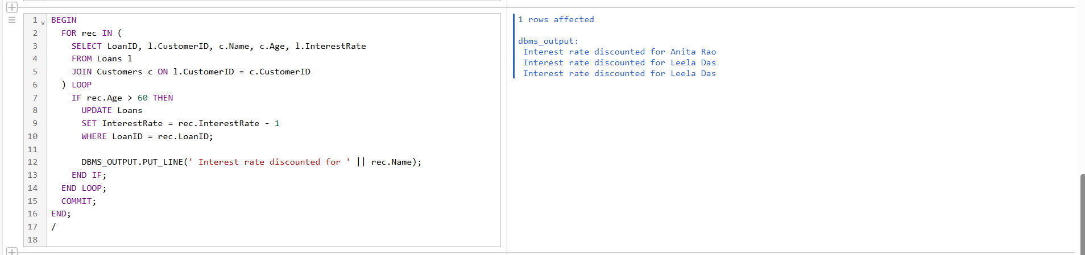
Scenario 2: A customer can be promoted to VIP status based on their balance.

Question: Write a PL/SQL block that iterates through all customers and sets a flag IsVIP to TRUE for those with a balance over $10,000

BEGIN
FOR rec IN (
SELECT CustomerID, Name, Balance FROM Customers
) LOOP
IF rec.Balance > 10000 THEN
UPDATE Customers
SET IsVIP = 'TRUE'
WHERE CustomerID = rec.CustomerID;

DBMS_OUTPUT.PUT_LINE(' ' || rec.Name || ' has been promoted to VIP status.');
END IF;
END LOOP;
COMMIT;
END;
/
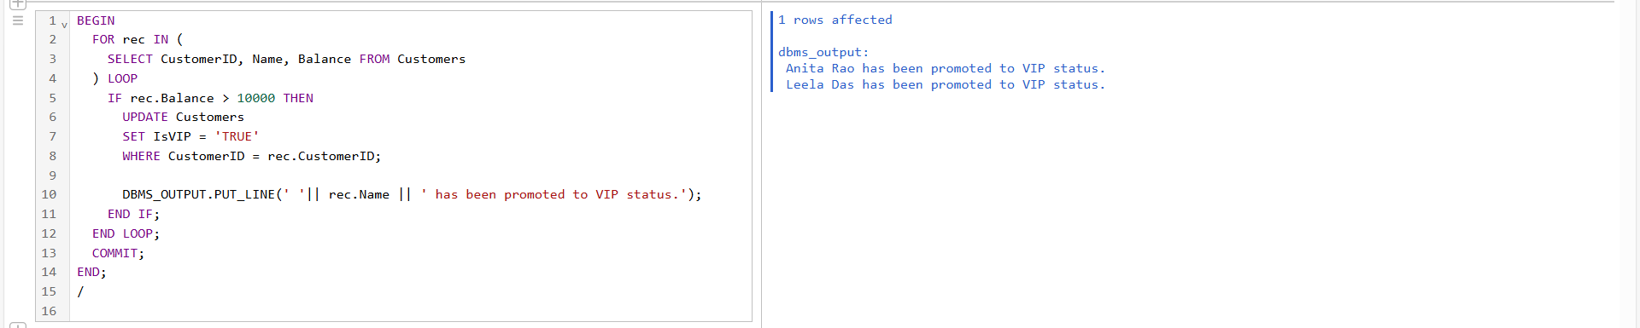

Scenario 3: The bank wants to send reminders to customers whose loans are due within the next 30 days.
Question: Write a PL/SQL block that fetches all loans due in the next 30 days and prints a reminder message for each customer.

BEGIN
FOR rec IN (
SELECT c.Name, l.LoanID, l.DueDate
FROM Loans l
JOIN Customers c ON l.CustomerID = c.CustomerID
WHERE l.DueDate BETWEEN SYSDATE AND SYSDATE + 30
) LOOP
DBMS_OUTPUT.PUT_LINE(
' Reminder: Loan ' || rec.LoanID || ' for ' || rec.Name ||
' is due on ' || TO_CHAR(rec.DueDate, 'DD-Mon-YYYY')
);
END LOOP;
END;
/
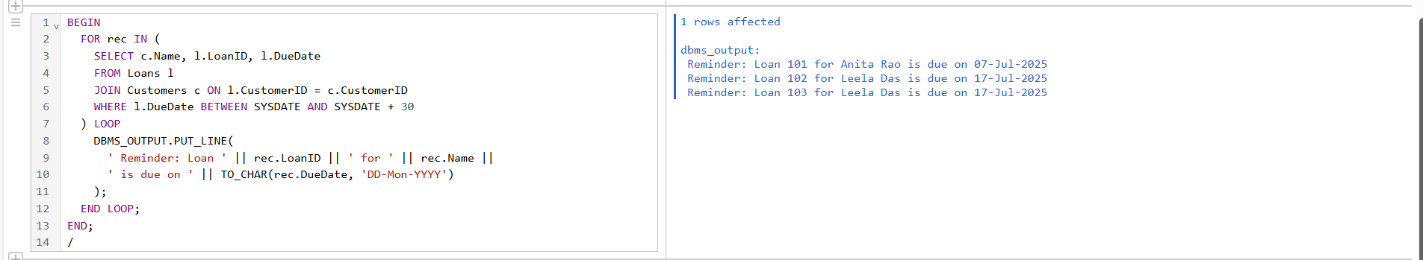
_________________________________________________________________________________

Exercise 3: Stored Procedures

Scenario 1 : The bank needs to process monthly interest for all savings accounts.

Question : Write a stored procedure ProcessMonthlyInterest that calculates and updates the balance of all savings accounts by applying an interest rate of 1% to the current balance.
CODE :

CREATE TABLE Accounts (
AccountNumber NUMBER PRIMARY KEY,
CustomerName VARCHAR2(50),
Balance NUMBER,
AccountType VARCHAR2(20)
);
INSERT INTO Accounts VALUES (101, 'Navya', 20000, 'Savings');
INSERT INTO Accounts VALUES (102, 'Moon', 15000, 'Savings');
INSERT INTO Accounts VALUES (103, 'Raj', 10000, 'Current');
INSERT INTO Accounts VALUES (104, 'Riya', 25000, 'Savings');
COMMIT;
SELECT * FROM Accounts;
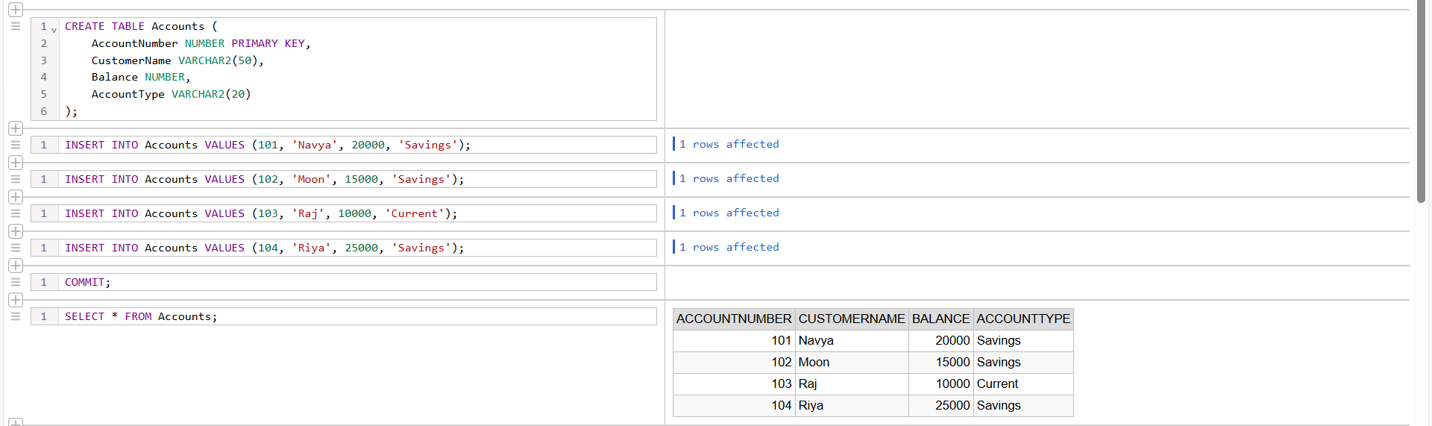
CREATE TABLE Employees (
EmpID NUMBER PRIMARY KEY,
Name VARCHAR2(50),
Department VARCHAR2(30),
Salary NUMBER
);
INSERT INTO Employees VALUES (1, 'Anil', 'IT', 50000);
INSERT INTO Employees VALUES (2, 'Sneha', 'HR', 40000);
INSERT INTO Employees VALUES (3, 'Megha', 'IT', 52000);
COMMIT;
SELECT * FROM Employees;
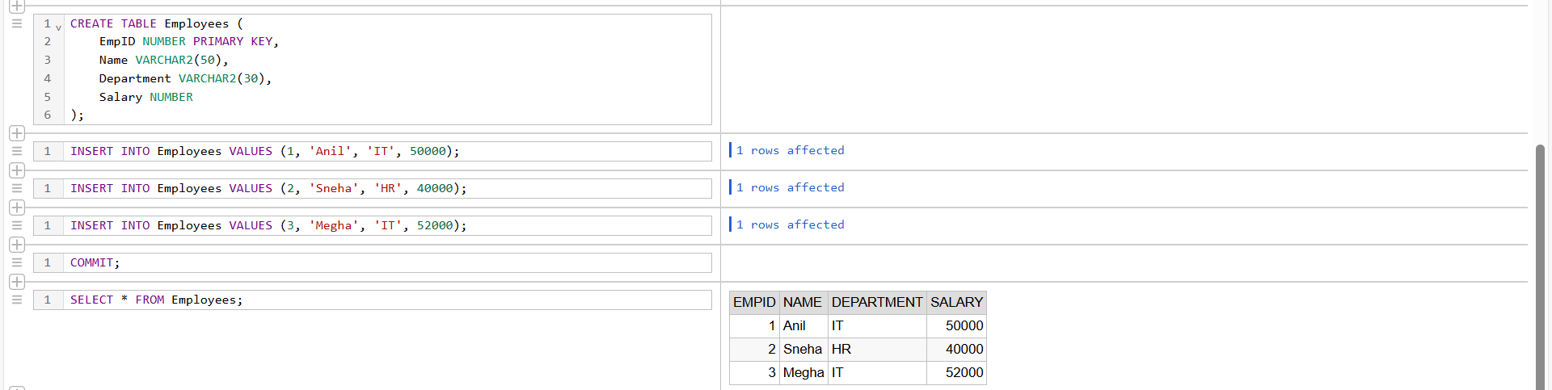

BEGIN
FOR acc IN (
SELECT AccountNumber, Balance FROM Accounts WHERE AccountType = 'Savings'
) LOOP
UPDATE Accounts
SET Balance = acc.Balance + (acc.Balance * 0.01)
WHERE AccountNumber = acc.AccountNumber;

DBMS_OUTPUT.PUT_LINE('Interest applied to Account ' || acc.AccountNumber);
END LOOP;
COMMIT;
END;
/
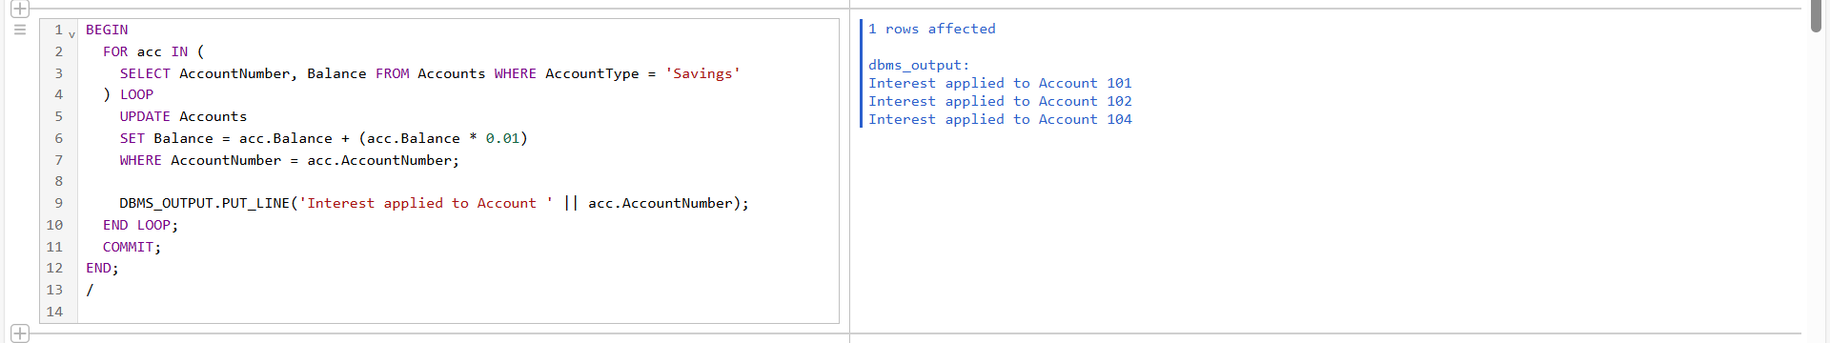
Scenario 2 : The bank wants to implement a bonus scheme for employees based on their performance.

Question : Write a stored procedure UpdateEmployeeBonus that updates the salary of employees in a given department by adding a bonus percentage passed as a parameter.

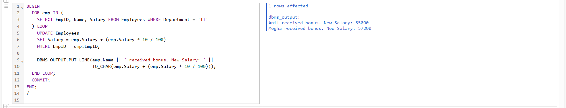
BEGIN
FOR emp IN (
SELECT EmpID, Name, Salary FROM Employees WHERE Department = 'IT'
) LOOP
UPDATE Employees
SET Salary = emp.Salary + (emp.Salary * 10 / 100)
WHERE EmpID = emp.EmpID;
DBMS_OUTPUT.PUT_LINE(emp.Name || ' received bonus. New Salary: ' ||
TO_CHAR(emp.Salary + (emp.Salary * 10 / 100)));
END LOOP;
COMMIT;
END;
/
Scenario 3 : Customers should be able to transfer funds between their accounts.

Question : Write a stored procedure TransferFunds that transfers a specified amount from one account to another, checking that the source account has sufficient balance before making the transfer.

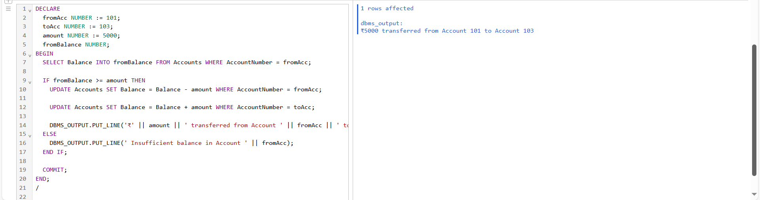
DECLARE
fromAcc NUMBER := 101;
toAcc NUMBER := 103;
amount NUMBER := 5000;
fromBalance NUMBER;
BEGIN
SELECT Balance INTO fromBalance FROM Accounts WHERE AccountNumber = fromAcc;
IF fromBalance >= amount THEN
UPDATE Accounts SET Balance = Balance - amount WHERE AccountNumber = fromAcc;
UPDATE Accounts SET Balance = Balance + amount WHERE AccountNumber = toAcc;
DBMS_OUTPUT.PUT_LINE('₹' || amount || ' transferred from Account ' || fromAcc || ' to Account ' || toAcc);
ELSE
DBMS_OUTPUT.PUT_LINE(' Insufficient balance in Account ' || fromAcc);
END IF;
COMMIT;
END;
/

_________________________________________________________________________________

TDD USING JUNIT – 5 AND MOCKITO

Junit_Basic Testing Exercises :

Exercise 1 : Setting Up JUnit

Scenario : You need to set up JUnit in your Java project to start writing unit tests. Steps: 1. Create a new Java project in your IDE (e.g., IntelliJ IDEA, Eclipse). 2. Add JUnit dependency to your project. If you are using Maven, add the following to your pom.xml: junit junit 4.13.2 test 3. Create a new test class in your project.
CODE :
pom.xml

<project>
<modelVersion>4.0.0</modelVersion>
<groupId>Navya</groupId>
<artifactId>myartifactid</artifactId>
<version>0.0-SNAPSHOT</version>
<dependencies>
<dependency>
<groupId>junit</groupId>
<artifactId>junit</artifactId>
<version>4.13.2</version>
<scope>test</scope>
</dependency>
</dependencies>
</project>

Calculator.java

public class Calculator {
public int add(int a, int b) {
return a + b;
}
public int subtract(int a, int b) {
return a - b;
}
}
CalculatorTest.java

import org.junit.Test;
import static org.junit.Assert.assertEquals;
public class CalculatorTest {
@Test
public void testAddition() {
Calculator calc = new Calculator();
int result = calc.add(10, 5);
assertEquals(15, result);
}
@Test
public void testSubtraction() {
Calculator calc = new Calculator();
int result = calc.subtract(10, 5);
assertEquals(5, result);
}
}
Main.java
public class Main {
public static void main(String[] args) {
Calculator calc = new Calculator();
int add = calc.add(10, 5);
int sub = calc.subtract(10, 5);
System.out.println("Running Calculator Tests...");
if (add == 15) {
System.out.println(" testAddition passed");
} else {
System.out.println(" testAddition failed. Expected 15 but got " + add);
}
if (sub == 5) {
System.out.println(" testSubtraction passed");
} else {
System.out.println(" testSubtraction failed. Expected 5 but got " + sub);
}
}
}
OUTPUT :

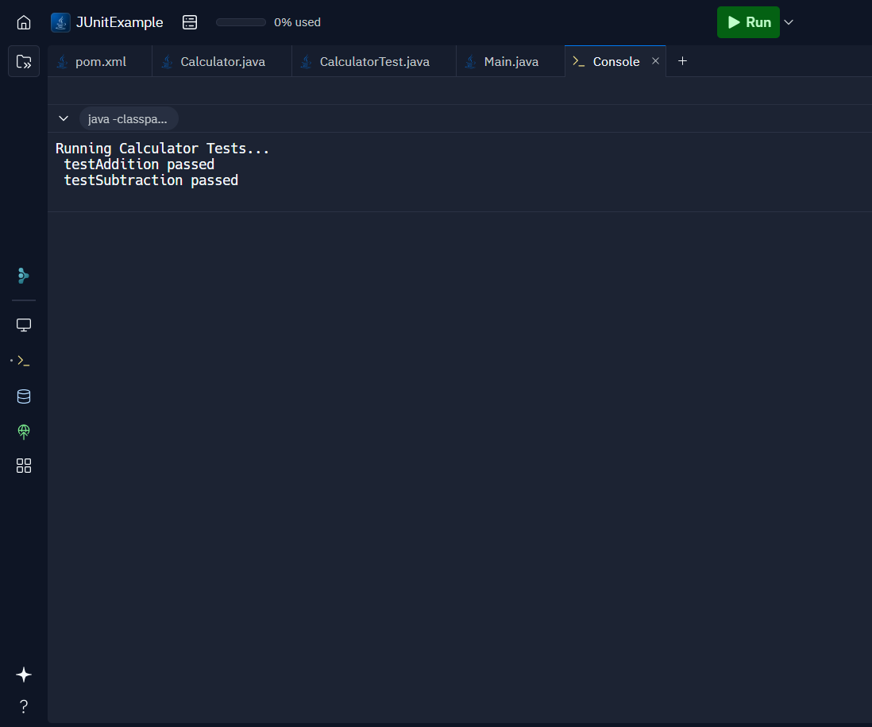
_________________________________________________________________________________

Exercise 3: Assertions in JUnit

Scenario : You need to use different assertions in JUnit to validate your test results.

Steps:
1. Write tests using various JUnit assertions.
Solution Code:
public class AssertionsTest {
@Test public void testAssertions() {
// Assert equals
assertEquals(5, 2 + 3);
// Assert true
assertTrue(5 > 3);
// Assert false
assertFalse(5 < 3); /
/ Assert null
assertNull(null); /
/ Assert not null
assertNotNull(new Object());
}
}

CODE :

pom.xml

<project>
<modelVersion>4.0.0</modelVersion>
<groupId>Navya</groupId>
<artifactId>myartifactid</artifactId>
<version>0.0-SNAPSHOT</version>
<dependencies>
<dependency>
<groupId>junit</groupId>
<artifactId>junit</artifactId>
<version>4.13.2</version>
<scope>test</scope>
</dependency>
</dependencies>
</project>
AssertionsTest.java

import org.junit.Test;
import static org.junit.Assert.*;
public class AssertionsTest {
@Test
public void testAssertions() {
// Assert equals
assertEquals(5, 2 + 3);
// Assert true
assertTrue(5 > 3);
// Assert false
assertFalse(5 < 3);
// Assert null
assertNull(null);
// Assert not null
assertNotNull(new Object());
}
}
Main.java

public class Main {
public static void main(String[] args) {
System.out.println(" Running Simulated Assertions Test...");
if (2 + 3 == 5) System.out.println(" assertEquals passed");
else System.out.println(" assertEquals failed");
if (5 > 3) System.out.println(" assertTrue passed");
else System.out.println(" assertTrue failed");
if (!(5 < 3)) System.out.println(" assertFalse passed");
else System.out.println(" assertFalse failed");
Object obj = null;
if (obj == null) System.out.println(" assertNull passed");
else System.out.println(" assertNull failed");
Object obj2 = new Object();
if (obj2 != null) System.out.println(" assertNotNull passed");
else System.out.println(" assertNotNull failed");
}
}
OUTPUT :
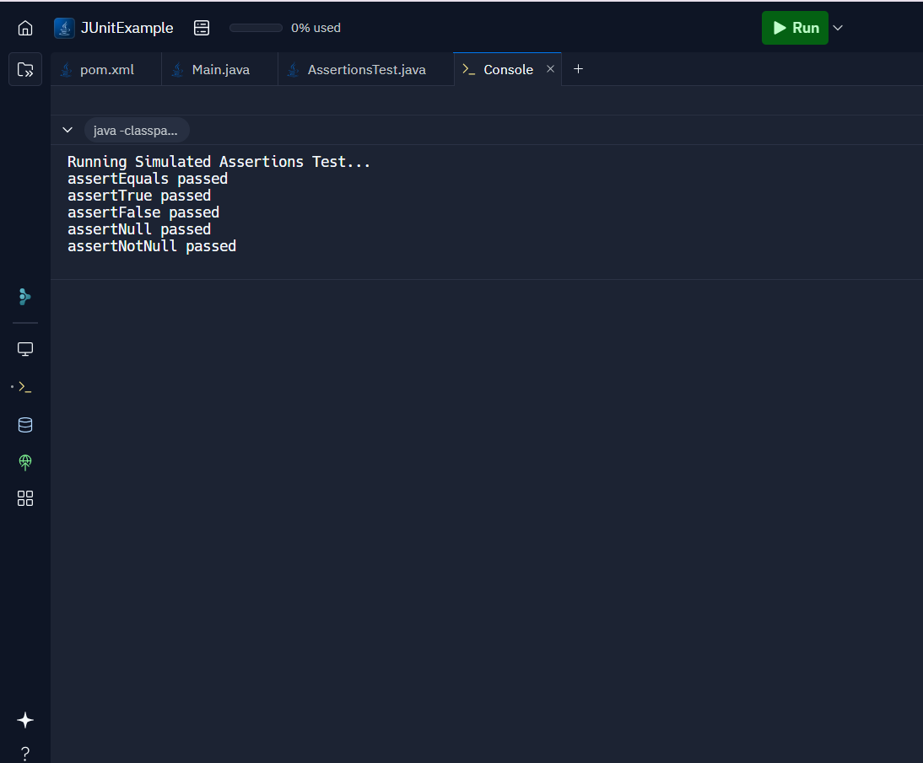

_________________________________________________________________________________

Exercise 4: Arrange-Act-Assert (AAA) Pattern, Test Fixtures, Setup and Teardown Methods in JUnit

Scenario : You need to organize your tests using the Arrange-Act-Assert (AAA) pattern and use setup and teardown methods.
Steps :
1. Write tests using the AAA pattern.
2. Use @Before and @After annotations for setup and teardown methods.

Calculator.java

public class Calculator {
public int add(int a, int b) {
return a + b;
}
public int multiply(int a, int b) {
return a * b;
}
}
CalculatorTest.java

import org.junit.After;
import org.junit.Before;
import org.junit.Test;
import static org.junit.Assert.*;
public class CalculatorTest {
private Calculator calc;
@Before
public void setUp() {
System.out.println("Setting up Calculator instance...");
calc = new Calculator();
}
@After
public void tearDown() {
System.out.println("Cleaning up after test...\n");
calc = null;
}
@Test
public void testAddition() {
int result = calc.add(4, 6);
assertEquals(10, result);
System.out.println(" testAddition passed");
}
@Test
public void testMultiplication() {
int result = calc.multiply(3, 5);
assertEquals(15, result);
System.out.println(" testMultiplication passed");
}
}

Main.java
public class Main {
static Calculator calc;
public static void setUp() {
System.out.println(" Setting up Calculator instance...");
calc = new Calculator();
}
public static void tearDown() {
System.out.println(" Cleaning up after test...\n");
calc = null;
}
public static void testAddition() {
setUp();
int result = calc.add(4, 6);
if (result == 10) {
System.out.println(" testAddition passed");
} else {
System.out.println(" testAddition failed");
}
tearDown();
}
public static void testMultiplication() {
setUp();
int result = calc.multiply(3, 5);
if (result == 15) {
System.out.println(" testMultiplication passed");
} else {
System.out.println(" testMultiplication failed");
}
tearDown();
}
public static void main(String[] args) {
System.out.println(" Running Simulated AAA Tests...\n");
testAddition();
testMultiplication();
}
}
OUTPUT :
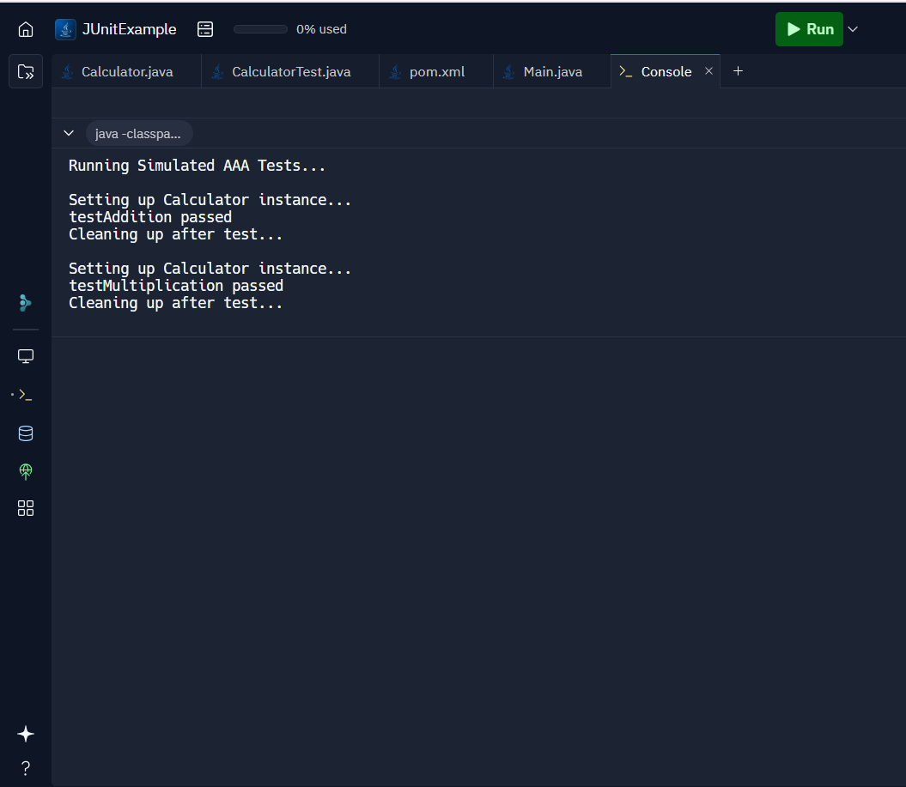
_________________________________________________________________________________

Mockito Exercises :

Exercise 1: Mocking and Stubbing

Scenario : You need to test a service that depends on an external API. Use Mockito to mock the external API and stub its methods.
Steps :
1. Create a mock object for the external API.
2. Stub the methods to return predefined values.
3. Write a test case that uses the mock object.

Main.java

// Step 1: Define ExternalApi interface
interface ExternalApi {
String getData();
}
// Step 2: MyService depends on ExternalApi
class MyService {
private ExternalApi api;
public MyService(ExternalApi api) {
this.api = api;
}
public String fetchData() {
return api.getData();
}
}
// Step 3: Simulated Test Case (Manual mocking & stubbing)
public class Main {
public static void main(String[] args) {
// Create mock object (manual)
ExternalApi mockApi = new ExternalApi() {
@Override
public String getData() {
// Stubbed method: return predefined value
return "Mock Data";
}
};
// Pass mock into MyService
MyService service = new MyService(mockApi);
// Simulate assertion
String result = service.fetchData();
if ("Mock Data".equals(result)) {
System.out.println(" testExternalApi passed");
} else {
System.out.println(" testExternalApi failed");
}
}
}
OUTPUT :
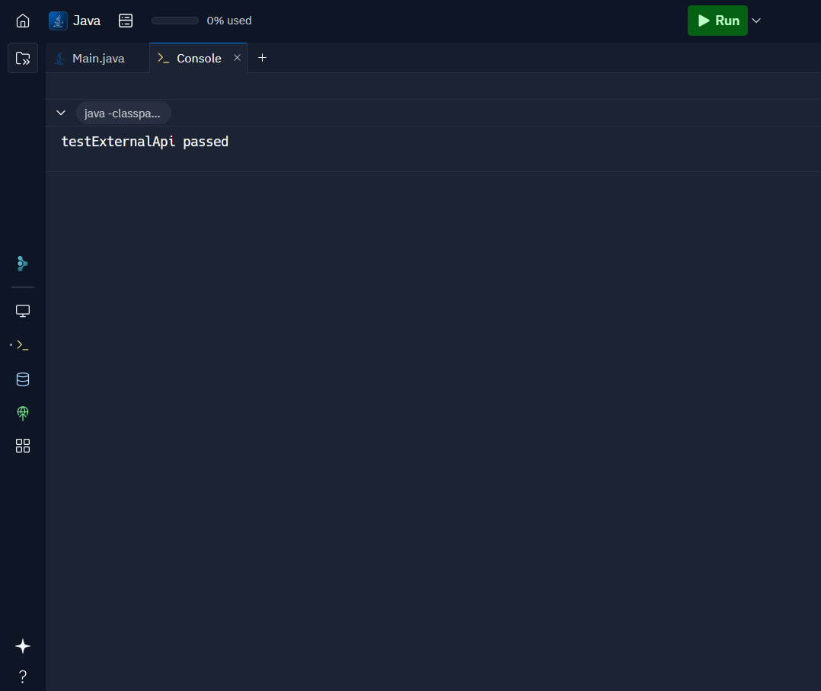

_________________________________________________________________________________

Exercise 2: Verifying Interactions

Scenario : You need to ensure that a method is called with specific arguments.
Steps :
1. Create a mock object.
2. Call the method with specific arguments.
3. Verify the interaction.

Main.java

// Step 1: ExternalApi interface with tracking variable
interface ExternalApi {
String getData();
}
// Step 2: Manual Mock that tracks interaction
class MockExternalApi implements ExternalApi {
boolean wasCalled = false;
@Override
public String getData() {
wasCalled = true; // Track call
return "Mock Data";
}
public boolean verifyCalled() {
return wasCalled;
}
}
// Step 3: Service class that uses the API
class MyService {
private ExternalApi api;
public MyService(ExternalApi api) {
this.api = api;
}
public String fetchData() {
return api.getData();
}
}
// Step 4: Simulated Test Case
public class Main {
public static void main(String[] args) {
// Create mock
MockExternalApi mockApi = new MockExternalApi();
// Call method
MyService service = new MyService(mockApi);
service.fetchData();
// Simulate verify(mockApi).getData()
if (mockApi.verifyCalled()) {
System.out.println(" Method getData() was called.");
} else {
System.out.println(" Method getData() was NOT called.");
}
}
}
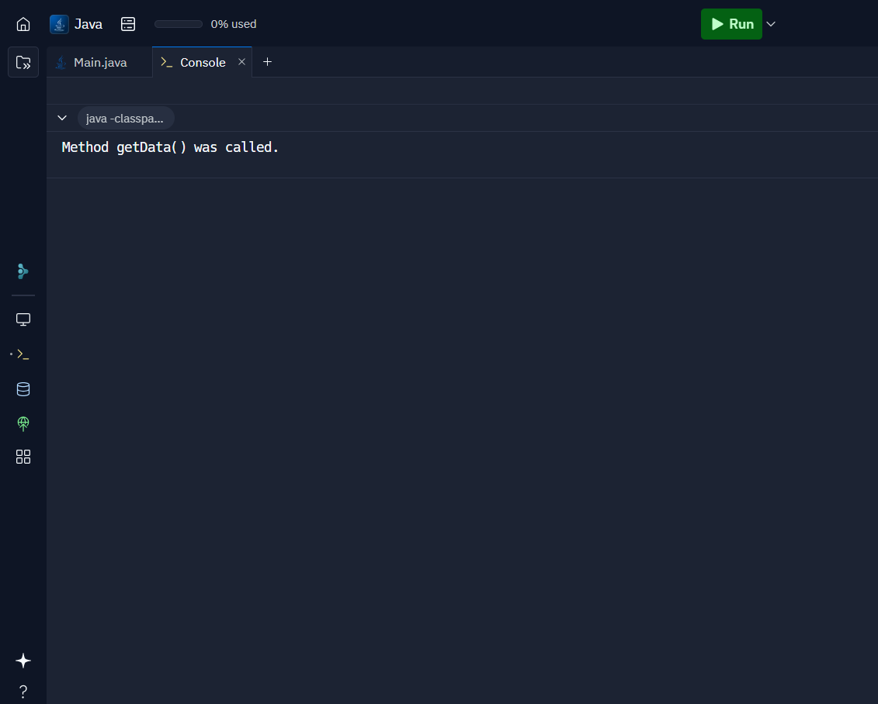
OUTPUT :

_________________________________________________________________________________

SL4J LOGGING FRAMEWORK

Exercise 1: Logging Error Messages and Warning Levels

Task : Write a Java application that demonstrates logging error messages and warning levels using SLF4J.

Pom.xml
<?xml version="1.0" encoding="UTF-8"?>
<project xmlns="http://maven.apache.org/POM/4.0.0"
xmlns:xsi="http://www.w3.org/2001/XMLSchema-instance"
xsi:schemaLocation="http://maven.apache.org/POM/4.0.0 http://maven.apache.org/xsd/maven-4.0.0.xsd">
<modelVersion>4.0.0</modelVersion>
<groupId>com.navya.logging</groupId>
<artifactId>LoggingExample</artifactId>
<version>1.0-SNAPSHOT</version>
<properties>
<maven.compiler.source>24</maven.compiler.source>
<maven.compiler.target>24</maven.compiler.target>
<project.build.sourceEncoding>UTF-8</project.build.sourceEncoding>
</properties>
<dependencies>
<!-- SLF4J API -->
<dependency>
<groupId>org.slf4j</groupId>
<artifactId>slf4j-api</artifactId>
<version>1.7.30</version>
</dependency>
<!-- Logback (SLF4J Implementation) -->
<dependency>
<groupId>ch.qos.logback</groupId>
<artifactId>logback-classic</artifactId>
<version>1.2.3</version>
</dependency>
</dependencies>
</project>
LoggerExample.java
package com.navya.logging;
import org.slf4j.Logger;
import org.slf4j.LoggerFactory;
public class LoggingExample {
private static final Logger logger = LoggerFactory.getLogger(LoggingExample.class);
public static void main(String[] args) {
logger.error(" This is an error message");
logger.warn(" This is a warning message");
}
}
OUTPUT :





